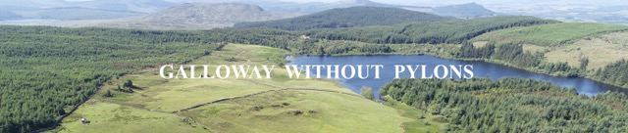

Representation for application ref. ECU00002128.

Glenlee to Tongland 132kV Reinforcement Project

Introduction

We are writing to highlight the widespread concerns about the proposed Kendoon to Tongland 132kV Reinforcement Project (KTR) proposed by Scottish Power Energy Networks (SPEN), the subsidiary of the Spanish energy giant Iberdrola and the significant adverse economic, environmental and visual effects that the Project will have on the area. We accept that the line needs to be updated, but the use of overhead pylons is opposed by many local groups including those concerned with: forestry protection, business, tourism, wildlife conservation, and the protection of historic sites. Alister Jack MP, several MSPs, members of the relevant community councils, local businesses, tourists and hundreds of people in the community have expressed their concerns about the overhead line and support our objective in persuading the Scottish Government and SPEN to underground the line.

Details of local support for undergrounding will be listed in a separate representation. (GWP repr. 2)

Galloway Without Pylons (GWP) has no objection to the Polquhanity to Glenlee overhead lines, planning applications ECU00002124/5/6/7, because these largely follow the original route and fulfil the guidelines set by the Holford Rules.

However, with regards to the Glenlee to Tongland section we believe that SPEN, right from the start of the process, should have also:

1. Abided by the “Holford Rules” ¹

2. Followed Iberdrola’s, Environmental Policy, Feb 2019, Environmental Commitments.

“The development of clean energy, investment in smart grids and other energy efficient technologies and respect for the environment are the pillars of the Group’s energy production model and distinguish the Company in the energy sector as one of the leading companies worldwide. The Company considers this environmental dimension as a priority in planning its businesses. This compels it to promote innovation, eco-efficiency and the gradual reduction of environmental impacts in the activities of the Group, in order for energy to become a sustainable driver of the economy and an ally of balanced development. Accordingly, aware of the importance of this factor in carrying out its corporate mission for its customers and shareholders and for other significant stakeholders with whom it interacts, the Company and the companies belonging to the Group undertake to promote innovation in this field and eco-efficiency (reduction of the environmental impact per production unit), i.e. to gradually reduce the environmental impacts of their activities, facilities, products and services, as well as to offer, promote and investigate”.

SPEN have shown no innovation or respect for the environment by choosing the cheapest option with a proposed overhead pylon line that passes through some of the most beautiful and iconic countryside in Dumfries and Galloway.

Reasons to Underground Transmission Lines.
- National Grid owns the national electricity transmission system in England and Wales (NETS). The NETS consists of approximately 4,474 miles of overhead line and 932 miles of underground cable. Therefore, 17% of the transmission system in England & Wales is underground.

- Undergrounding, throughout the world, has become a common method of delivering transmission lines and in the UK, National Grid are even removing pylons to assist the tourist industry.

- We accept that undergrounding is more expensive to install and faults can take longer to repair and in certain circumstances, can cause more land disturbance, in the short term, but usually requires a narrower corridor to install.

- Underground cables have lower transmission losses and can more readily absorb emergency power loads. This is increasingly becoming more important as more intermittent wind and solar feeds the grid.

- Undergrounding preserves natural beauty and land value. The lines are out of sight, which answers one of the main concerns for overhead lines (OHL) - aesthetic impact. While impacts vary depending on the location, OHL permanently alter the look of residential neighbourhoods, scenic areas and historical sites.
Aesthetic impact is just one of the factors that cannot be mitigated against. The International Council on Large Electrical Systems, CIGRÉ, compared the impacts of the greatest environmental concern for OHL and underground cable lines (UGC) in its technical brochure 110²
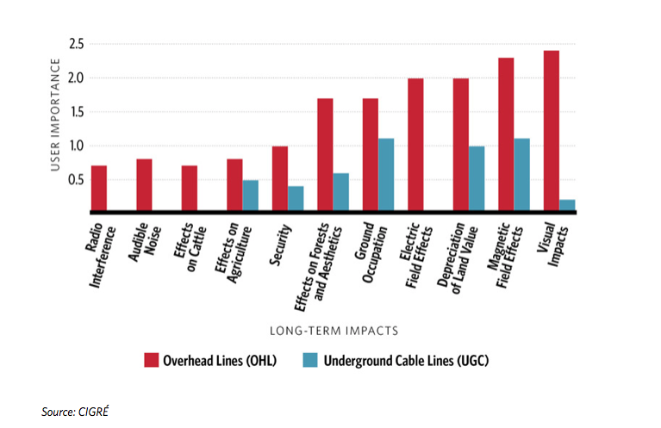
- Apart from the environmental and visual benefits, undergrounding reduces outages, as the line is not susceptible to damage from high winds, falling trees and lightning strikes. The latter is becoming more important as the earth’s magnetic shield has weakened significantly creating the possibility of grid threatening lightning strikes. The European Space Agency states that the earth’s magnetic field has lost 9% of its strength in the past 200 years. Climate change is likely to increase the occurrence of severe storms, which is another reason to go underground.

- Underground cables require less maintenance, which has a positive economic impact for local businesses.

OHL - is access to erect the pylons suitable?

GWP believes that the access to the proposed OHL is totally inappropriate owing to the increased construction traffic and the nature of the villages and road infrastructure. Furthermore, the anticipated construction period of 58 months, would be extremely detrimental to the tourist industry, which the area relies on so much. Tourists are unlikely to return for the duration of the construction period if they have a negative experience during their initial stay.

The proposed widening of country roads and lanes as shown in the planning application will alter the unique charm and character of the area as well as damaging roadside trees, some of them which are extremely old and precious.

A fact that was hidden from the public was the construction time scale. At a meeting in the Laurieston Village Hall in May 2018, SPEN when asked how long the construction period would last replied, approximately two years. We now find out from the planning application that the project will take 58 months! This could easily extend to 6 or 7 years.

Recent Developments

National Grid, Undergrounding high voltage electricity transmission lines ³
The costs of underground cable systems vary and have been the subject of much debate and discussion. In January 2012 the Institute of Engineering and Technology (IET) and Parsons Brinkerhoff published the findings of an independent study into the costs of new electricity transmission infrastructure. The report analysed the costs of installing and maintaining new high voltage transmission circuits under the ground, under the sea and overhead. The report found that, excluding build costs, the cost of operation, maintenance and energy losses over the life of the connection was broadly the same for undergrounding and overhead lines. However, the report also concluded that the capital build costs on their own vary greatly, depending on terrain, route length and power capacity.
The use of underground cables has a long-term positive visual impact when compared with the use of overhead lines (OHL), and in some instances this will be the preferred choice. However, undergrounding has other impacts that should be considered, such as environmental and socio- economic factors.

In 2014 National Grid unveils plans to bury cables underground. BBC News⁴
Pylon cables will disappear from some of the most beautiful areas of England and Wales as part of a move by National Grid to reduce the impact of energy transmission on the landscape.
Twelve stretches of pylons in eight areas of countryside have been shortlisted for the beauty treatment.
The move follows a consultant's report identifying the ugliest overhead lines in the land.
Countryside groups welcomed the move but stressed that all new power projects must consider the impact on the landscape from the outset. The protests against new wind farms drew National Grid's attention to the public dislike of pylons in the landscape.

It has responded by setting aside £500m, made available by energy industry regulator Ofgem until 2021, to bury high voltage cables, or screen them, or re-route them away from beauty spots.

Among the contenders for early investment are sites in four national parks: the New Forest, Brecon Beacons, the Peak District and Snowdonia and four areas of outstanding natural beauty in Dorset, the High Weald, the North Wessex Downs, and the Tamar Valley.

Sarah Harris from National Grid told BBC News:
"Initially we assessed 571 km of transmission lines of our overhead lines in Areas of Outstanding Natural Beauty and national parks”.

An advisory group is helping with the process. It comprises organisations including the Campaign for National Parks, Campaign to Protect Rural England (CPRE), Campaign to Protect Rural Wales, English Heritage, Cadw, Natural England and the National Trust.

Nick Clack, senior energy campaigner at CPRE, told BBC News:
"This is a really positive step in reducing the impact of existing overhead electricity lines in some of our most valued countryside. Given these welcome efforts to mitigate the impact of existing lines, National Grid needs to make sure it is doing all it can to mitigate the impact of new ones. Close consultation and cooperation should be applied across all regulated industries so that landscape impacts arising from big infrastructure projects are properly considered and funding is provided at the outset."

Iberdrola

SPEN’s owners, Iberdrola announced in January 2018 that they had inspected 65,000km of power lines in Spain to ensure security of supply. 11,300km were underground power lines.

“These inspections are designed to detect potential problems in the components of its installations, e.g. insulators, conductors, iron fittings, pylons, etc., caused by lightning, fallen trees, construction work or buildings close to the lines, etc.”

Iberdrola are used to working with underground cables and it is interesting to read the likely hazards that can impact pylons ie. lightening, trees and construction work. Iberdrola appears to have more problems with overhead than underground lines!

Undergrounding is the most effective form of mitigation where a new line is inevitable. Any additional expense in investment in UGC can be justified with consideration to the need to protect areas of high amenity value

Evidence from other projects

Orsted’s Hornsea 4, off-shore wind farm project (in planning) ⁵
After the cables come to shore in East Yorkshire they will then travel 40km, under ground to a National Grid substation. Under grounding was selected right from the beginning of this project resulting in 79% of the community consultation respondents saying that the onshore infrastructure was suitable with appropriate mitigation.

Triton Knoll, off-shore wind farm.⁶
Another off shore wind farm (Lincs.) where the cables travel from the shore to a substation 57 km away. The underground cables, like the Orsted Hornsea 4 project, do not pass through either a national park or an area of outstanding national beauty.

In comparison SPEN’s preferred UGC route from Glenlee to Tongland is 38km.

Beauly – Denny Project
In January 2010 the Scottish Government sanctioned the construction of a new overhead transmission line (the Beauly-Denny link) through the newly designated Cairngorms National Park and an additional number of smaller areas of high amenity value, despite strong objections from a number of campaign groups and the Cairngorms National Park Authority. The inquiry reporters referred to the Holford Rules and noted that the scheme failed to comply with the Rules in at least two significant respects. The developers’ proposed scheme was however accepted largely at face value. The Scottish Government approved the line in the face of more than 20,000 objections and now a 220 km. scar has been left across stunning landscape. We have an opportunity to learn from this experience.

Scottish & Southern Electricity Networks Transmission
SSEN Transmission have received funds from Ofgem’s to remove 12km of overhead transmission lines from the Cairngorms National Park. The two sections of overhead lines, near the villages of Boat of Garten and Nethy Bridge, will see 46 transmission towers removed from the Cairngorms landscape, with both circuits to be replaced with underground cabling.

The investment required to carry out both schemes totals £31.9m and is being funded as part of a £500m scheme administered by the energy regulator, Ofgem. The scheme allows the three GB electricity transmission owners to bid for funding to mitigate the impact of historic electricity infrastructure in National Parks and National Scenic Areas.

SPEN Undergrounding at Gatehouse of Fleet ^{7.Photo}
Overhead power lines in the Fleet Valley National Scenic Area are being removed. SPEN district manager, Iain Steele said,

“the modernisation would boost the area’s natural appeal and the local tourist industry. We have worked hard to engage with the local community and other stakeholders throughout the process”.

This is a statement from SPEN explaining the process.

“SPEN’s distribution business is currently undertaking a replacement of the existing 33kV wood pole overhead line from the existing distribution substation at Gatehouse to Upper Rosko Bridge. The works involve installing 8.5km of 33kV underground cable of which 7.5km is along the B796 Gatehouse to Creetown Road. Once the cable is installed the 33kv overhead line from Gatehouse substation to Upper Rosko will be removed (this equates to 101 wooden poles). The works are currently on going and are planned to finish later this year. Following energisation of the new underground cable, the wood pole line will be removed during the early part of 2021. Further to this, a second 33kV wood pole overhead line (of approximately 4.5km) will also be undergrounded in this area during 2021.

SPEN is delivering these works through its distribution price control period (known as RIIO-ED1) which requires Distribution Network Operators (DNOs) to look closely at the potential for undergrounding of existing overhead lines within areas designated at national level for landscape and visual amenity. In Scotland, this focuses on areas designated as National Parks and National Scenic Areas (NSAs). The overhead lines in question sit within the Fleet Valley NSA”.

If the pylons are being removed to boost the local economy then the current pylons must hinder the local economy! SPEN are taking down 101 wooden poles (with more planned to come down later) but plan to install 118 giant pylons (26-35m high) from Glenlee to Tongland through an important tourist area.

GWP cannot stress enough to the Scottish Ministers how dismayed and angry the local community are with SPEN and the OHL proposal. They are removing established wooden poles in one area (and under grounding the line) while proposing the erection of new giant pylons in another, which is basically part of the same Galloway tourist catchment area.

There are many examples throughout the UK where existing pylons, not necessarily in need of modernisation, are being removed to enhance the natural beauty of the countryside, which in turn will assist the tourist economy of the area

If the OHL goes ahead how long will it be before there is a clamour to remove them and place them underground. Dumfries and Galloway needs consideration now by not using pylons in the first place.

SPEN state in their Under Ground Cable Study.

“It is acknowledged by SPEN that the underground option is, in each case, technically feasible and, on balance, environmentally preferable having regard to landscape and visual as well as forestry impacts”.

Therefore, the decision is all about money. SPEN say that the underground line from Glenlee to Tongland will cost £95.96 million more than the overhead line. This has been calculated by SPEN so there is a possibility that an independent body would come to a different figure. Also, potential cable route options were identified by Cable Consulting International Ltd. using a combination of desktop and site survey analyses.

Why should £96 million be invested in Dumfries & Galloway

Amortised over the 60/70 year life expectancy of the line and with extremely low financing costs, the extra amount is small especially when you consider that the wind farm subsidy scheme is paying wind turbine owners, on average, seven times the value of the electricity they generate and is likely to cost UK consumers an estimated £1.4 billion until the scheme ends. Furthermore, constraint payments (shutting down wind farms when they are producing more electricity than the grid can cope with) has cost, according to the Renewable Energy Foundation, the UK taxpayer £130 million in 2019 and £607 million over the past decade.

Undergrounding is worth the extra investment, as it is an investment, not just an extra cost, for the following reasons:
1. Woodland protection.
SPEN have stated that in order for these pylons to be built an 80m wide corridor through a woodland landscape is required. This would result in the felling of thousands of trees. However, if the cable were underground a much narrower corridor would be needed, minimising the impact on our woodland.
SPEN’s Environmental Impact Assessment Report (EIAR), Chapter 8, Forestry states

“There is a wide range of broadleaf woodlands within the Glenlee to Tongland connection of the KTR Project. The sensitivity of these areas of broadleaf, including ASNW and NWSS, it is overall considered to be high as while the woodlands are in variable condition, many are designated within the ASNW or NWSS database and therefore highly valued. The magnitude of the effect is deemed major based on the extent of the change to these areas of broadleaf woodlands. As such, without mitigation, the significance of the effect is considered to be major”.

ASNW: Ancient & Semi-Natural Woodland
NWSS: Native Woodland Survey of Scotland

2. Wildlife conservation
The RSPB have stated that they have significant concerns about the potential collision risk for nightjars. 95% of the Scottish population of this protected species is to be found in Dumfries and Galloway. THE RSPB also have concerns for raptors including, golden eagles, osprey, goshawks and red kites.

Birds of Conservation Concern 4 (BOCC4) was compiled by a partnership of organisations, including the British Trust for Ornithology, Countryside Council for Wales, Game & Wildlife Conservation Trust, Joint Nature Conservation Committee, Natural England, Northern Ireland Environment Agency, RSPB, Scottish Natural Heritage and the Wildfowl & Wetlands Trust.

On their latest review BOCC4, the red list (highest conservation priority) list lapwing, curlew, black grouse, woodcock, cuckoo and merlin. BOCC4 amber list (the second most critical) list osprey, nightjars and tawny owls. All these birds on the red and amber list breed and live in the area of the proposed OHL.

Many land mammals found near the OHL route are included in the Scottish Governments Bio Diversity List. Water vole, brown hare, otter, pine marten, red squirrels and a variety of bats are listed either for conservation action or where negative action should be avoided.

The Bio Diversity list also includes the following reptiles/amphibians where negative action should be avoided. These are the common toad, great crested newt, palmate newt, slow worm adder and common lizard. All are found in the area of the OHL and just to give one example, thousands of toads can be seen in late summer on forestry tracks in the area, tracks that will accommodate heavy construction vehicles for the access to the pylon sites and quarries.

GWP are concerned that the authors of the Environmental Impact Assessment Report (EIAR), Land Use Consultants, because of their over reliance on “desk top studies” have been too ready to either scope out certain species, such as great crested newts and water voles or to downgrade those species, such as pine martens and red squirrels, that have been noted as being under a significant threat at the local study area, to non/not significant after additional mitigation measures. We are concerned that the mitigation measures are not as robust as LUC indicate.

3. National Park Status
For years individuals and groups have been campaigning for Galloway to be given National Park status. If this is successful, The Galloway National Park Association says it could generate up to £60 million a year for the region’s economy and help support 1,400 jobs. The construction of this new, much more visually intrusive, pylon line will undoubtedly have a negative impact on any application. National Parks in England have successfully removed pylons and replaced them with underground cables.

4. The Dumfries and Galloway Regional Tourism Strategy, 2016-2020 ⁸
Councillor Colin Smyth, Chair of the Dumfries and Galloway Council’s Economy, Environment and Infrastructure (EEI) committee said

“Dumfries & Galloway Council has made building the local economy our number one priority and there is no more important contributor to that aim than the tourism sector. It is no exaggeration to say that when tourism does well the economy of Dumfries & Galloway does well. That is why, along with the businesses in the sector and our many partners and stakeholders, our Council is committed to the ongoing support for the tourism sector to assist with developing further growth, employment and income for our tourism businesses across the whole of Dumfries & Galloway”.

Tourism is worth £302 million per year to the local economy supporting 7,000 jobs. Tourism is an extremely important contributor to the economic and social sustainability of the area, but the OHL threatens the Council’s strategy to grow the economy through nature-based tourism

5. Climate Change
On the 27th June 2019 Dumfries & Galloway Council declared a climate emergency. The motion sets out a 12 point plan to reinvigorate the pursuit of net zero carbon emissions in our region, protect our fragile biodiversity and our natural environment. The 12 point plan includes:

Point 7.
We recognise the importance of our biodiversity and natural environment in our drive to reduce the impact of climate change and will encourage and support practices to enhance and sustain the farmed and natural world.

Point 8.
We will embrace innovative measures and respond as a priority to technological advances, which can reduce our region’s impact on climate change. This will enable opportunities to contribute to the economic development and diversity of our region by supporting businesses and communities, which can benefit from schemes and projects, which support our priority to tackle climate change.

Point 12
In recognition of Dumfries and Galloway Council’s commitment to our Climate Change Declaration on eliminating carbon emissions, protecting our region’s biodiversity and natural environment we will appoint an elected member as our Environment Champion.

D & G Council’s target of net zero carbon by 2025 is supported by a range of companies and organisations including:
Drax, Natural Power, NFU Scotland, South of Scotland Enterprise, SEPA, Scottish Fire and Rescue Services, Sustainable Scotland Network, Energy Agency, Crichton Carbon Centre and last but not least SP Energy Networks

Sept. 2020. Dumfries & Galloway College has launched a £1.8 million Green Energy Hub to promote sustainable economic growth, increased air quality and other aspects of environmental forward planning in the region.
Helped by financing from SP Energy Networks’ Green Economy Fund, the hub was officially opened by Principal Joanna Campbell and SP Energy Networks’ Chief Executive, Frank Mitchell, who were joined by local MSP, Joan McAlpine at the ceremony.

GWP are delighted to see SP Energy Networks involved in promoting net zero carbon, the protection of the environment and the economic development and diversity of the region but we would like to see their words put into action by being innovative and undergrounding the Glenlee to Tongland OHL. By doing so SPEN would not only contribute to their objectives in meeting the D&G Councils 12 point plan (of which they are a supporter) but also fulfilling their findings from the underground report that undergrounding is better for ecology, tourism, amenity and for the future.

The views of local organisations

The following extracts are taken from the literature of the various organisations that have been set up to look after the Galloway landscape, increase tourism and to help protect the environment for future generations.

Dumfries and Galloway Council, D & G ‘Galloway Forestry & Woodland Strategy’
“Forestry, woodlands and trees are an important part of our cultural and natural heritage. They contribute to the local economy providing jobs and creating wealth. They inspire artists, evoking strong emotions and reactions from visitors and residents alike. They offer opportunities for recreation and tourism, reflection and adventure.
Forests and woodlands affect the natural processes that control our air, land and water. For example, they store carbon that otherwise might change the climate; they can help keep our rivers and water supplies clean; and they can assist in preventing excessive flooding and soil erosion.
Trees can enhance our streets and open spaces, defining views, softening harsh buildings, providing shade and shelter, seasonal interest and contact with nature. Some types of trees are capable of supporting more biodiversity than any other terrestrial habitats and are also a link to our past, often indicating previous land-uses or industrial processes”.

Galloway and Southern Ayrshire Biosphere
“The Biosphere covers 5,200 square kilometres and was granted its status in recognition of its special qualities, from sweeping upland areas and blanket bog formations-one of the least interrupted and undisturbed mire systems in Europe-to lush forests and agricultural land. Its rural communities occupy the radiating river valleys. The Biosphere is home to 95,000 people who work together to improve life whilst caring for the natural environment.

Galloway Glens Landscape Partnership
“Tourism is a vital local industry, and a significant local employer. This programme of work will seek to work with the existing visitor economy to increase the profile of the area. Projects include the Dark Skies visitor centre in Kirkcudbright, visitor experiences to witness Galloway craft and artisan producers and the branding and marketing of Loch Ken as a visitor destination”.

Scottish Rural Action.
“A high quality of life and the sustainability of rural communities and our economy depend on the positive management and protection of biodiversity, eco-systems and natural landscapes. We call for: Local authority and community planning and decision-making processes to give consideration to the views of local environmental and wildlife champions, as well as land managers, and to support the protection, restoration and enhancement of Scotland’s environmental assets”. Communities should have greater power over the decisions which affect them in relation to energy production, supply and distribution, particularly where there is potentially significant environmental damage as a consequence”.

Southern Uplands Partnership.
“You can disappear into the Southern Uplands mountainous heart, its forests, open country, towns and villages and enjoy the wealth of history, heritage and wildlife. With the majority of Scotland's population and international airports only a few hours drive way, more and more people are discovering what the locals already know, that this is a remarkable area to explore, where the profound links between the cultural and natural heritage can be experienced. Walkers love the feeling of remoteness up on the hills and the open vistas from the tops. A great variety of short and long distance routes have been created for walking, mountain biking, cycling and riding and a number have exciting contemporary art installations dramatically placed in the landscape”.

Forestry Commission, Scotland
“Forestry Commission Scotland's (FCS) mission is to protect and expand Scotland's forests and woodlands and increase their value to society and the environment. The Scottish Forestry Strategy is the Scottish Executive’s framework for taking forestry forward through the first half of this century and beyond. It sets out a vision of a forestry sector that is diverse and strong; in tune with the environment; employing many people in a wide range of enterprises; and providing the many other services and benefits that people need, now and for the future”.

“We want to make it easier for people to get the most out of the nation’s forests. We maintain more than 1200km of walking tracks and 130 cycle routes – not forgetting the visitor centres and wildlife viewing spots we’ve established across the country. We even employ landscape architects to help us design forests that are nicer to look at”.

Visit Scotland
Top 5 free and paid visitor attractions in Dumfries and Galloway (with visitor numbers), 2018
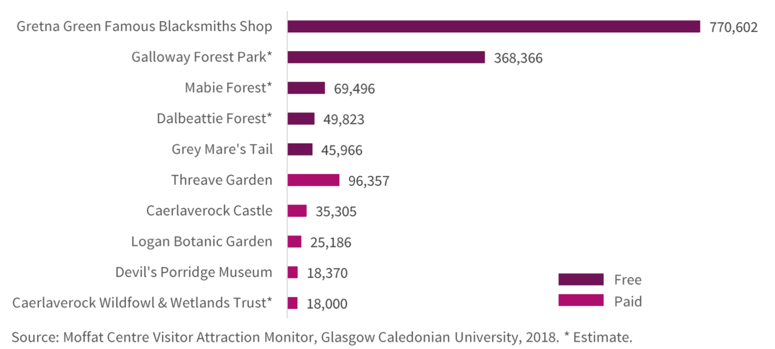

The OHL goes through the Galloway Forest Park, the second most popular visitor attraction in Dumfries and Galloway.

Dumfries and Galloway Leader
The Scottish Rural Development Programme (SRDP) 2014-2020 funds economic, environmental and social measures for the benefit of rural Scotland. It is part of the EU Common Agricultural Policy (CAP) and is funded by the European Commission and the Scottish Government. The key purpose of the SRDP is to help achieve sustainable economic growth in Scotland’s rural areas. Its main priorities are:

- Enhancing the rural economy
- Supporting agricultural and forestry businesses
- Protecting and improving the natural environment
- Addressing the impact of climate change
- Supporting rural communities

Scottish Tourism Alliance
“Tourism is acknowledged by the Scottish Government as being Scotland’s most important industry. The tourism industry is a cornerstone of the Scottish Economy, and vital to the economic performance of towns, cities and regions across the length and breadth of Scotland”.

South of Scotland Enterprise (SOSE)
This organisation has recently committed just over £2.7 million to support the recovery and future of the economy in the South of Scotland. The agency’s first major investment will run over 5 years to support a new tourism, marketing and destination development programme to be delivered by a new industry led leadership body: the South of Scotland Destination Alliance (SSDA). Professor Russel Griggs OBE, chair of SOSE said,

“This is a landmark investment and one which confirms our commitment to being ambitious and bold for our region. As well as helping the Covid recovery, we are looking ahead to get us to a place where we will be attracting more people than ever to visit, stay and spend in the South of Scotland and in a manner which is sustainable and amplifies the many wide reaching benefits tourism gives rise to”.

Galloway Glens Landscape Partnership.
“The future for the Galloway Glens area will be determined by man’s direct and indirect influence on the landscape”. “Though it is not possible to stop change, it is sometimes possible to guide changes in our landscape for the purposes of improving it or maintaining valuable aspects”.

All the above organisations are working tirelessly to protect and improve the environment and at the same time trying to assist the economy by developing the tourist industry. The proposed OHL passes over or close to areas that are very important to the tourist economy in Dumfries and Galloway, these are some of them:

Queen’s Way Crossing.
This is a section of the A712 between New Galloway and Newton Stewart, the gateway into the Galloway Forest Park. This road is also the main road entrance to the Galloway Forest Dark Sky Park, which is one of the “darkest” skies in the world as well as access to three visitor centres at Clatteringshaws Loch, Glentrool and Kirroughtree.

Raiders Road.
A 10 mile two-way forest drive, which is open to vehicles between April and October and for walkers, cyclists and horse-riders all year-round. There are various places to stop along Raiders' Road the jewel being the Otter Pool.

Otter Pool.
One of the highlights of the Raiders Road attracting more than 30,000 visitors a year. A £100,000 improvement project was completed in August 2020 to cope with the increasing visitor numbers. Neil Murray, manager with Forestry and Land Scotland’s south regional team said,

“Since the Otter Pool site originally opened, there has been a tenfold increase in visitor numbers. Its been a great partnership exercise and everyone involved has helped to ensure that the Raiders Road Forest Drive continues to be a rare opportunity for everyone to access and enjoy one of the wildest part of south west Scotland”.

Stroan Loch.
A popular tourist attraction close to the Stroan Viaduct, which was built for the Portpatrick Railway, which opened in 1861. Today the viaduct forms part of the walk from Mossdale to Loch Skerrow. The “Port Road Line” or “Paddy Line” is idyllic with stunning views. The old viaduct is the start of the scenic but strenuous Buzzard Trail.

Bennan, Slogarie and Laurieston Forests.
All three forests are part of the Galloway Forest Park and are an important area for tourists especially for walking, cycling, horse riding and fishing. The three forests are also breeding grounds for a range of endangered species both avian and animal, including goshawk, nightjar, red kite, pine marten and amphibians including great crested newts.⁹ In fact, Dumfries & Galloway can boast all nine of the terrestrial species of amphibians and reptiles occurring in Scotland.

Galloway Kite Trail. (GKT)
The results of an RSPB six-year study¹⁰ show the significant economic impact made by the GKT to the surrounding local communities, and broader area of Dumfries & Galloway. In 2009, the GKT introduced almost £700,000 of new spend into the local economy, supporting almost 20 full time equivalent jobs. In addition, these economic impacts illustrate only one aspect of the varied benefits offered by the GKT to the local community. The full range of benefits of a site such as this involves health, educational, and cultural benefits that are much harder to quantify, but no less important for it. Nevertheless, the continuing, and increasing, economic and employment contribution makes a profound case for prioritising investment in the GKT, and other similar sites for wildlife recreation, in D&G.

Red Kite Feeding Station, Laurieston
This is a major tourist attraction in the area and the OHL pylons will be seen from the feeding station as they leave Laurieston Forest traversing over open farmland towards Nielson’s Monument. The farmland contains evidence of bronze age archaeology and is an important breeding ground for lapwing, curlew and sand martins.

Neilsons Monument.
Dedicated to James Beaumont Neilson (1792-1865), who invented the hot-blast process for iron making. The monument is 10.6 metres high and affords superb views from Barstobrick Hill. This site at Barstrobrick has been inhabited for over 1500 years when an ancient Iron Age Hill Fort was built there.

Laurieston to Gatehouse of Fleet Road, C13.
"From this point one should certainly go on to Gatehouse. The road is one of the most heaven-kissing in Galloway", extract from Highways and Byways in Galloway and Carrick, 1916. The OHL passes over the C13 very close to Kenick Burn, which is a popular picnic and walking area. The C13 is also a favourite road in D & G for cyclists and horse riding. The C13 boasts a double avenue of ancient overhanging beech trees. OHL construction traffic would go through them to erect 19 pylons and to access 3 quarries. This is totally unacceptable.

A75 Crossing.
This is the main access route for tourists from Dumfries to Stanraer and on to Northern Ireland.
A survey carried out by YouGov on behalf of the John Muir Trust (JMT)¹¹ found that 55% of
Scottish adults were “less likely” to visit scenic areas in Scotland if they contain large scale
infrastructure, like commercial wind farms, electricity transmission and super quarries.

Stantec UK Ltd¹² who prepared the likely socio-economic, tourism and recreational effects for SPEN say:
“Most overnight visits to Dumfries and Galloway over this period were domestic (95%). This region therefore has the highest proportion of domestic tourism across all of Scotland. This reinforces the importance of the scenery and landscape of the area”.

Therefore it is SPEN’s responsibility to innovate with a project that respects this sentiment.

Conclusions

Dumfries and Galloway is one of the most deprived areas in Scotland and the region’s full time
workers receive the lowest average weekly pay in Scotland and any action that could aggravate the
situation has to be avoided at all cost.

From the start of this consultation SPEN should have made undergrounding their default position
which would have been supported by the vast majority of people in the communities involved. Instead, SPEN have ignored the needs and desires of the people who live and work in the area and simply gone for the cheapest overhead route. Notwithstanding SPEN’s published approach to routeing major electrical infrastructure projects, the Scottish Ministers, in their Scoping Opinion (October 2017), stated that within the EIA report for the KTR Project SPEN should:

“include information on alternative measures, including undergrounding, which have been considered to avoid, prevent or reduce and if possible offset the likely significant adverse landscape and visual effects where these have been identified through consultation feedback from affected communities or the routeing process e.g. ‘pinch points’ or cumulative effects on sensitive receptors”.

SPEN published an under grounding report in July 2020 which, as previously stated, said that:

“It is acknowledged by SPEN that the underground option is, in each case, technically feasible and, on balance, environmentally preferable having regard to landscape and visual as well as forestry impacts”.

A decision to underground would fulfil Iberdrola’s ambitions of being innovative and wanting to reduce negative impacts on the environment.

SPEN have decided that the extra £96 million is too much for an investment in Dumfries and Galloway, which amounts to approximately £1.5 million p.a. over the lifetime of the project.

SPEN have labelled the extra cost for undergrounding as £96m but they haven’t presented a full Cost Benefit Analysis (CBA) in their planning application. We think it is essential that an independent CBA be carried out so that a legitimate cost difference between an OHL and a UGC can be considered.

SPEN say the extra cost is £96m but what is the real cost? These following factors must be considered in a CBA to determine the “real cost” of the project.

- Initial investment costs of both OHL and UGC
- Operation and maintenance savings resulting from an UGC
- Reliability value of the UGC compared to the OHL
- Aesthetic value to residents of UGC compared with OHL
- Safety issues related to both UGC and OHL
- Value of lost tourism revenue with the OHL during the construction phase.
- Value of lost tourism revenue after completion during the lifetime of the of the project (legacy cost)

GWP believe that this is a major flaw in SPEN’s presentation to the Scottish Government and that the process should be rejected on these grounds alone.

When the consultation process started SPEN had consistently stated that the new OHL was to modernise and to increase capacity. Increased capacity to utilise extra generation from future wind farms which would facilitate exporting electricity to England. The Consultation Round Three Document dated October 2017 stated:

“This reduced scheme (relating to the 400kV Auchencrosh to Harker proposal) involves the modernisation and increase in capacity of the existing 132kV overhead line between Kendoon and Glenlee and from Glenlee to Tongland”

This consultation document was then the blueprint for discussions with SPEN during the public consultation period from November 20th 2017 until January 26th 2018. This fact was also made clear at SPEN’s presentation in Laurieston in May 2018.

SPEN now say that the Glenlee to Tongland line is not to increase capacity but is just to modernise the infrastructure. This is a fundamental change in the main function of the project and stakeholders have believed for the past 4 years that the Glenlee to Tongland line was to increase capacity.

This raises the following questions?
- Has the economic situation changed.
- Has the future projection for new wind farms decreased.
- Will energy production, as governments try to grasp a policy that balances intermittent renewables with reliable supply, also change course? It now appears that the UK government is on the verge of investing up to £2 billion into small nuclear reactors designed by Rolls Royce.¹³

Therefore, SPEN could have either:

- Simply modernised the two single circuit lines from Glenlee to Tongland and from Tongland to Dumfries. Job done, probably with few or no objections,
or

- If removal of the Tongland to Dumfries line is a major advantage then modernising the existing Glenlee to Tongland OHL, incorporating the undergrounding of those sections where the extra height of the pylons was detrimental to the environmental concerns of the area, should have been investigated first. It should be noted here that SPEN’s preferred underground route from Glenlee to Tongland follows more or less the existing OHL. This is because the topography and access is far easier than the proposed OHL that we strongly oppose.

We believe that the Scottish Ministers should have been able to see both these options that follow the Holford Rules and that they should have been fully costed independently so that a comparison could be made with SPEN’s OHL application.

It is unreasonable to state that a full assessment of alternatives has been undertaken when in actual fact SPEN’s "preference" has dictated the final design of the Project.
Neither of these options has been pursued so Galloway Without Pylons propose that the Glenlee to Tongland section of the KTR Project is undergrounded in its entirety. The area has a very high amenity value and should be protected rather than damaged and the economy should be stimulated rather than threatened.

Addendum
This is an extract from SPEN’s EIAR, Chapter 15, Socio-economics, Tourism and Recreation:
“At the time of writing (August 2020), the tourism and recreation sector has recently been badly impacted by the COVID-19 pandemic, with almost complete lockdown of the sector from March – July 2020. Research jointly commissioned by the UK devolved national tourism agencies (July 2020) indicates that with the easing of lockdown measures there is evidence of a short term increase in bookings for self-catered accommodation and ‘staycation’ activities for the remainder of the 2020 season, with particular demand in Scotland, but international tourism remains heavily restricted and the overall level of tourism activity in the UK is likely to remain substantially below pre-pandemic levels for several years”.

GWP agrees with SPEN’s understanding of the situation and we believe that any action that could compromise the tourist industry and the economic recovery of Dumfries & Galloway should be avoided if at all possible or at the very least, postponed until the recovery is complete and the economic impact and energy requirements have been evaluated This sentiment applies to an overhead or underground line.

GWP would like to acknowledge the professionalism and co-operation of Stephen Jack, SPEN’s Environmental Planner, in response to the many questions that we have asked him over the past three years.

References
- Holford Rules. Rule 1. Avoid altogether, if possible, the major areas of highest amenity value, by so planning the general route of the line in the first place, even if the total mileage is somewhat increased in consequence. Note on Rule 1 (a) Investigate the possibility of alternative routes, avoiding altogether, if possible major areas of highest amenity value. The consideration of alternative routes must be an integral feature of environmental statements. If there is an existing transmission line through a major area of highest amenity value and the surrounding land use has to some extent adjusted to its presence, particularly in the case of commercial forestry, then effect of remaining on this route must be considered in terms of the effect of a new route avoiding the area.

- https://e-cigre.org/publication/110-comparison-of-high-voltage-overhead-lines-and-underground-cables-report-and-guidelines

- https://www.nationalgrid.com/uk/electricity-transmission/sites/et/files/documents/45349-Undergrounding_high_voltage_electricity_transmission_lines_The_technical_issues_INT.pdf

- https://www.bbc.co.uk/news/business-29989654

- https://orstedcdn.azureedge.net/-/media/www/docs/corp/uk/hornsea-project-four/community-consultation-leaflet-aug-19/190730_consultation-leaflet-aug-2019.ashx?la=en&rev=752d90bf67aa427882537457d6e19bcd&hash=78B34FA495C0BAE60C5E8C0F68825613

- https://www.tritonknoll.co.uk/onshore-cable/

- Photo, Galloway News
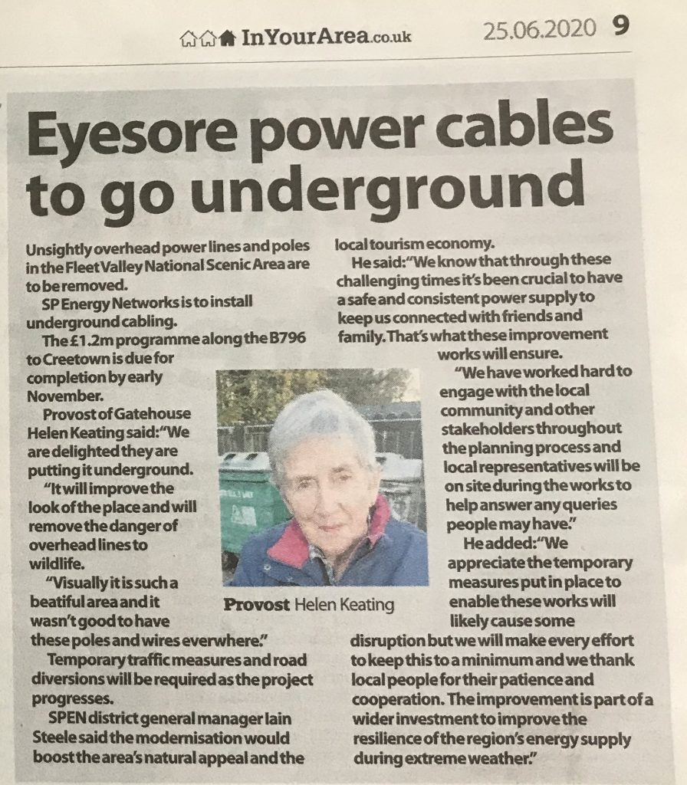

- https://www.dumgal.gov.uk/media/19228/Regional-Tourism-Strategy-2016-20/pdf/Dumfries___Galloway_Regional_Tourism_Strategy_2016-2020.pdf

- https://swseic.org.uk/what-to-see/dumfries-galloway/species/amphibians-and-reptiles/

- https://www.rspb.org.uk/globalassets/downloads/documents/positions/economics/the-galloway-kite-trail.pdf

- https://www.johnmuirtrust.org/latest/news/1205-poll-reveals-the-call-of-wild-places-to-visitors

- https://www.spenergynetworks.co.uk/userfiles/file/KTR_EIAR_Chapter_15_Socio-Economics_All_Files.pdf

- https://www.theguardian.com/business/2020/nov/11/rolls-royce-vows-to-create-6000-uk-jobs-with-nuclear-power-station-plans
https://www.futurenetzero.com/2020/09/08/dumfries-galloway-college-launches-1-8-million-green-energy-hub/

e-mail: info@gallowaywithoutpylons.org tel: 01644 450352 www.gallowaywithoutpylons.org

High Lochenbreck, Laurieston, Castle Douglas, Dumfries & Galloway, DG7 2PY

