Objections to SPEN’s KTR Project - an Equestrian Perspective

Why do people choose to live in and visit rural Galloway?

A safe, secure and welcoming place for adults and children? Superb scenery? Tranquillity? Rural sports and leisure activities? Colourful and rich history? Diverse and spectacular wildlife? Vibrant arts and culture?

When you consider the many reasons why people choose to visit, live, work and remain in this part of the world and then look at the impact that SPEN’s KTR project will have on this area, you see just how catastrophic this would be on almost every level. It is important to recognise the scale, length and breadth of damage that would be inflicted on our environment and to question the rationale behind such a development? In this locale, who will benefit from this assault on our surroundings? Indeed, where is the long-term justification of such a project; where is the will to preserve the landscapes that are Scotland’s richest assets; where is the control that ensures that large businesses adhere to Government principles about routing power-lines; where is the famous Scottish ingenuity and resourcefulness that finds clever ways to solve engineering challenges?

From a local horse-owner and rider’s perspective, the proposals are devastating. Not only will access to the wonderful hill and forest tracks be blocked (and those very tracks destroyed), but the day to day management and exercise of equines will become extremely limited and hazardous - and for four years!! We have already suffered the major impacts of forest harvesting and clearances - which have made roads lethal and forest tracks impassable - over a period of almost 10 years. For a horse-rider meeting a wood-lorry or a juggernaut carrying forest-clearing equipment on a narrow C-class road as we have between Laurieston and Gatehouse, it is a daunting and life-threatening experience. You cannot allow children to ride out on ponies. Visitors no longer bring horses to ride in our lovely hills and forests; it is too dangerous, but for those of us who live here and who keep our horses at home or in local livery stables, we have no option but to use such roads as access if we are going to exercise our horses and take advantage of the environment that attracted us to the area in the first place.

For a number of us, we have no choice but to take our horses onto the roads that SPEN will use to transport machinery, hardcore and base work substances and pylon materials over a period of four years. Personally, as someone who stables his horses at home in the village of Laurieston, I have to lead my horses along a short stretch of the B795 in order to get to the gate which gives access to the fields where the horses graze. I lead large, highly strung animals in and out of the gate and along the road four times each and every day and it is already a case of dicing with death because of the volume and speed of traffic; when SPEN start their works using this road, it will become a complete nightmare - and I have no choice, no alternative. Representations to the Council have had little effect; it appears that nothing will be done until there are accidents or fatalities. How much more likely are such disasters if SPEN is allowed to use these roads?
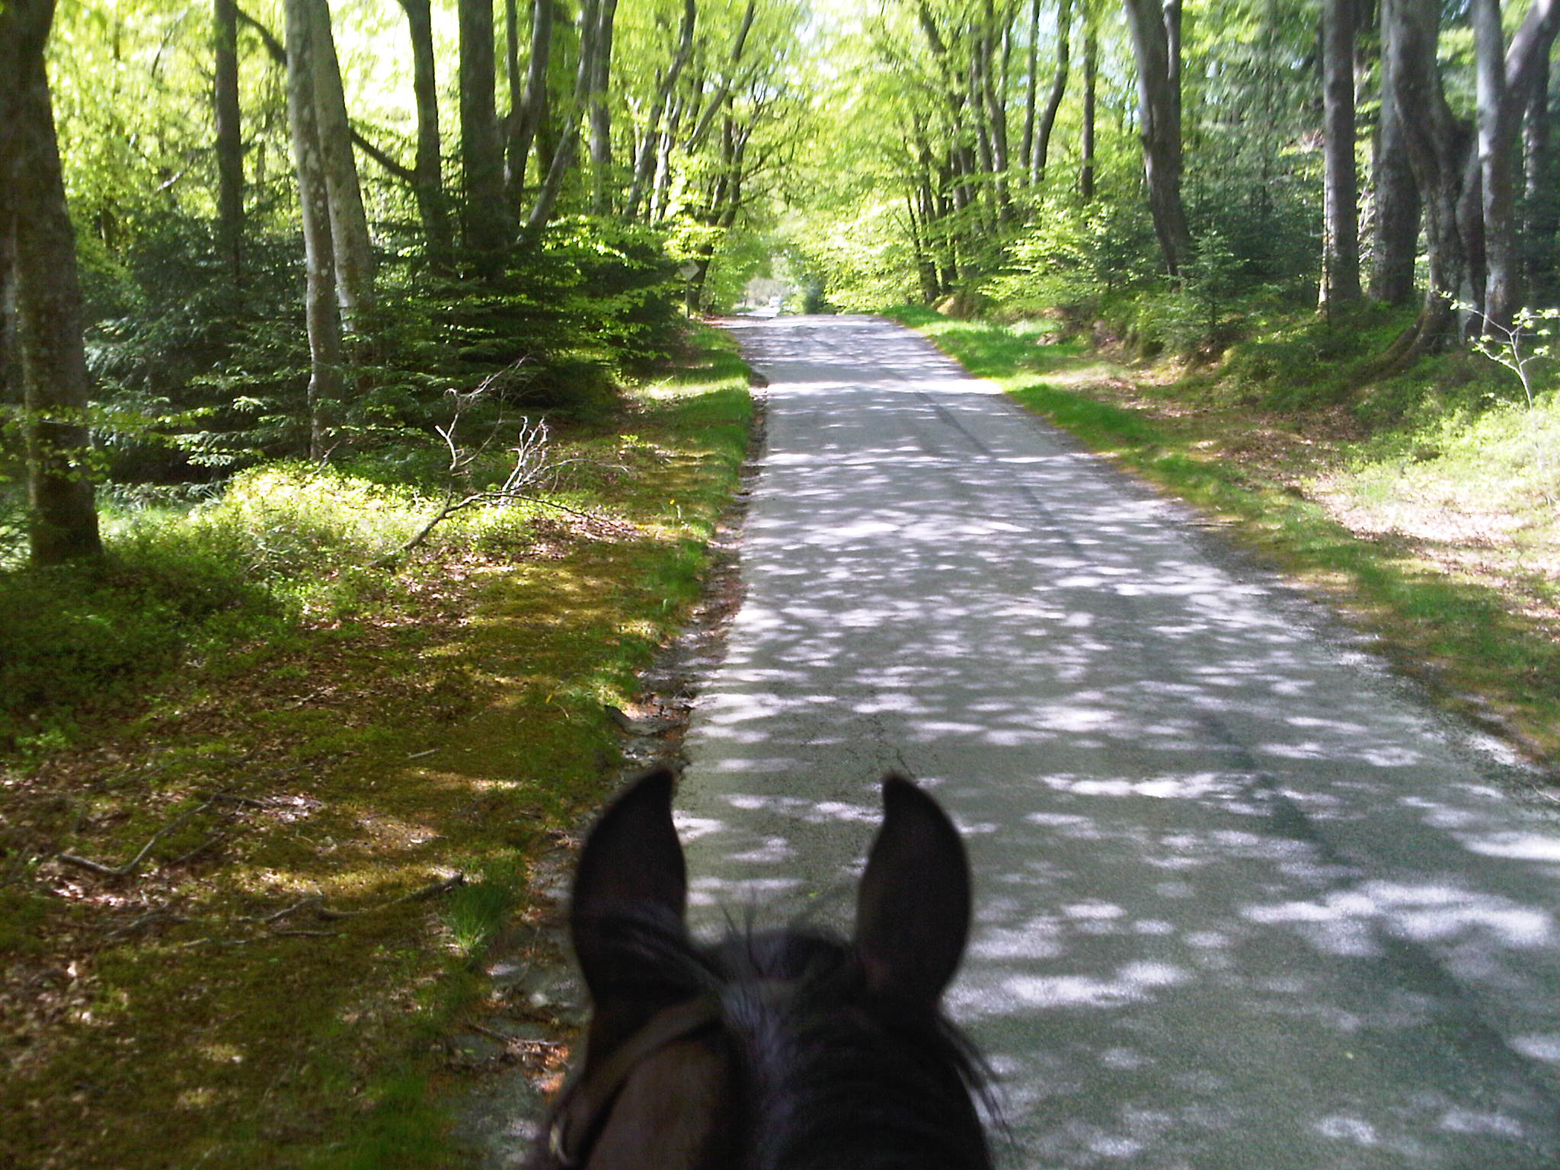
For those of us who have committed to living in and contributing to the community that is Laurieston and who have invested our resources in our homes and in our personal interests and leisure pursuits, SPEN’s proposals spell disaster. Not only will we suffer four or more years of disruption and danger, we will lose the very things that we cherish and which brought us here in the first place. If this sounds emotive, then it is because our lives and our well-being are threatened but, in the larger scheme of things, it is the wilful and scantily justified abuse of our unique and startlingly beautiful landscape that would be the greatest crime and it is our duty to safeguard this wonderful environment for future generations.

A view of the Beech Avenue on the Laurieston to Gathouse road which will be destroyed by the works proposed by SPEN.

DC Forbes
Laurieston

