Finlay Carson MSP
Member of the Scottish Parliament for Galloway and West Dumfries

1st October 2018

To whom it may concern.

As the Member of the Scottish Parliament for Galloway and West Dumfries, I am proud to serve, what I believe to be, Scotland’s most beautiful constituency. That is why I am committed to the campaign for Galloway to be designated as Scotland’s next National Park.

Our natural environment is one, if not our most, valuable asset therefore we should be bringing forward measures to protect and enhance our environment to attract tourists and new businesses to our region. Taking the easy option of overhead pylons would be detrimental to that ambition. It is clear to me, that local people whilst wanting security of power supply, do not want the huge infrastructure of pylons blighting our countryside. Our views should be taken seriously.

I am on record, requesting that Scottish Power Energy Networks must fully investigate running the power lines underground for the entire length of the KTR route to avoid our natural environment being spoiled for generations to come. I have made it clear when meeting with them that we need 21st century solutions. We do not look back in 20 years’ time and ask ourselves why we allowed old technology to be used.
Scotland is a country renowned for its natural beauty, its entrepreneurs and innovators. There is an opportunity to use this project to prove that we are still world leaders.

This campaign is hugely worthwhile and I will give my full backing to any option which removes the need for pylons.

Yours sincerely,

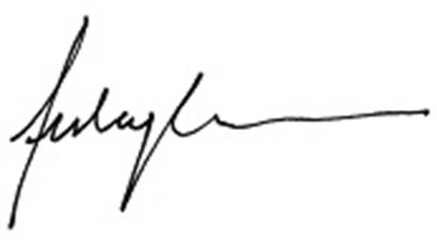

Finlay Carson MSP
Member of the Scottish Parliament for Galloway & West Dumfries

