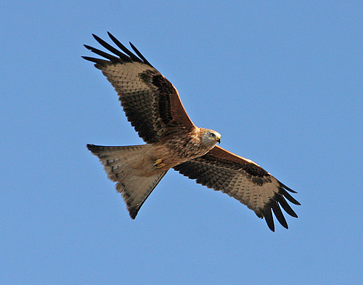
Red Kite Feeding Station

Bellymack Hill Farm
Laurieston
Castle Douglas
DG7 2PJ

The Red Kite Feeding Station has become a major tourist attraction and its success, apart from the red kites, is its wonderful panoramic views over the Galloway countryside

This experience will be degraded if the KTR Project goes overground as all our visitors will see the huge pylons as they come out of Laurieston Forest and continue south easterly towards Bargatton and beyond. Neilsons’s Monument, built in 1883, is a favourite landmark to see from Bellymack and the pylons will dominate the view especially as the monument is 10.6 m. high and the pylons will be up to 35m high.

I am also very concerned about the disruption the construction traffic will cause for all the tourists visiting Galloway, disruption that I believe could last for up to four years.

Anne Johnstone

14/09/2018

